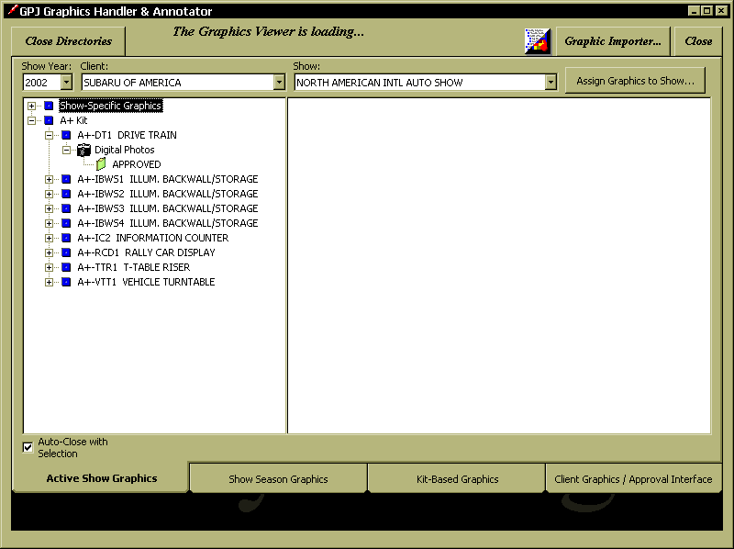
Currently, when Kit-based graphics exist for assigned Elements, the current graphics will display (not necessarily the graphics that went to the show).

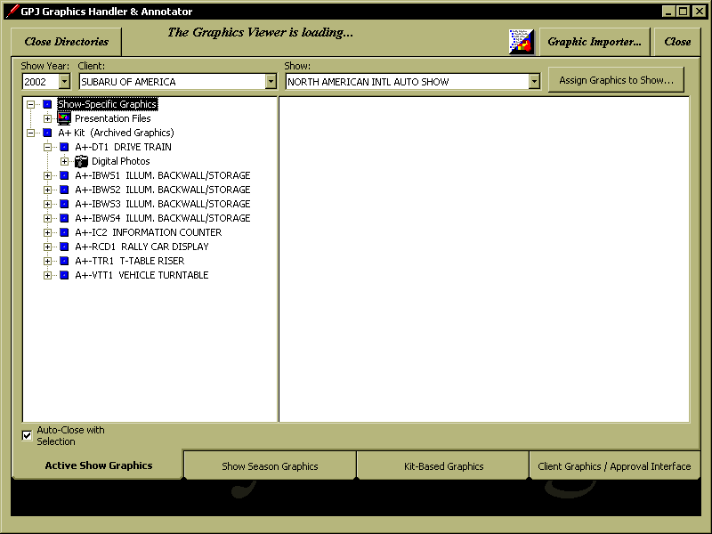
By writing Kit-based graphics to GFX_SHOW table at a specified date following closing of show, a “snapshot” of attending graphics will be captured and viewable. The Kit Heading will include “(Archived Graphics)”. The App will recognize the specified date, and only display “archived” Kit-based graphics.
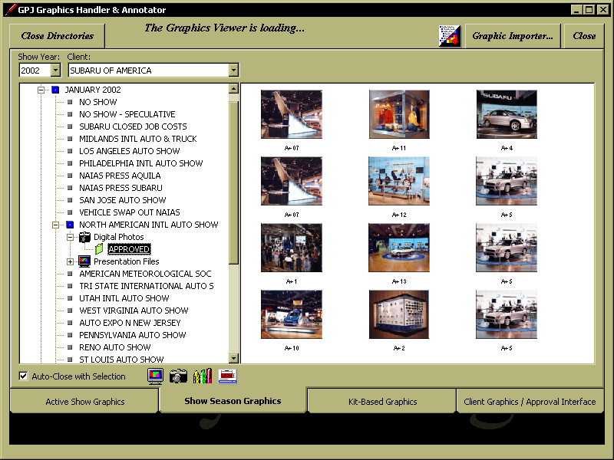
Now that the Kit-based graphics show up as Show-Specific graphics, should they be included in the “Show Season Graphics” tab view, or should they be filtered out (since Kit-based graphics do not show up). If they are left as viewable, they will not be associated with an Element in this view.

As shown in the above screen, if we retain the pointer to the Element, you will see multiples of graphics. If the Archived Kit-based graphics were filtered out, these duplicates would not show up.

